**Top Lifeguard Training Programs: What You Need to Know**

As a summer rapidly approaches, many people are looking to get their lifeguard certification through quality training programs. Whether you want to work at a local pool or on the beach, becoming a lifeguard is rewarding career that helps ensures safety in aquatic environments. Let's take a look at some of the top programs out there.

**Understanding the Essentials of Lifeguard Training**

One of the most important factors is finding a program conveniently located near you. American Lifeguard offers various locations across the country to make training accessible. With both indoor and outdoor pools available at different sites, students can choose classes matching their schedules and practice in similar conditions to where they plan to work. Being near home makes attending classes and practice sessions stress-free.



**Key Components of a Top Lifeguarding Training**

American Lifeguard's programs provide comprehensive [lifeguard training near me](https://americanlifeguard.com/) focused on safety. Students learn strong swimming skills, proper use of equipment like backboards, and how to perform rescues efficiently. Training dives and car rides prepare future guards for any emergencies. Extensive CPR and first aid training equips students to respond to injuries until EMS arrives. Practical skills are practiced until instructors feel students are ready for any situation in a supervised environment.

**How to Choose the Best Lifeguards Training Program for You**

In addition to water skills, American Lifeguard training delves into soft skills needed as a lifeguard like rule enforcement, risk management, communication, and customer service. Trainees role play common scenarios and learn how to defuse tensions to keep areas peaceful. Leadership modules discuss handling difficult behaviors, supervising others, and serving as a role model. These additional lessons teach how to confidently manage pools, beaches, and other areas.

**Benefits of Enrolling in a High-Quality Lifeguard**

American Lifeguard offers both open and private programs. The open programs run throughout the spring and summer on set start dates and provide certification upon completion. Private programs allow groups like camps, community centers or swim teams to reserve a training at their convenience for all their aquatic staff. Both provide the same high-quality instruction and result in certification through major organizations like American Lifeguard.

**The Role of Certification in Lifeguard Training Programs**

For those unable to attend on-site, American Lifeguard now provides a fully online option as well. The online components include instructional videos, virtual classrooms for discussion, and personal instruction via video call. Upon completion of coursework, students must then schedule to test and practice skills at a local facility in their area under the oversight of American Lifeguard's virtual instructors. The online program makes training possible anywhere with an internet connection.

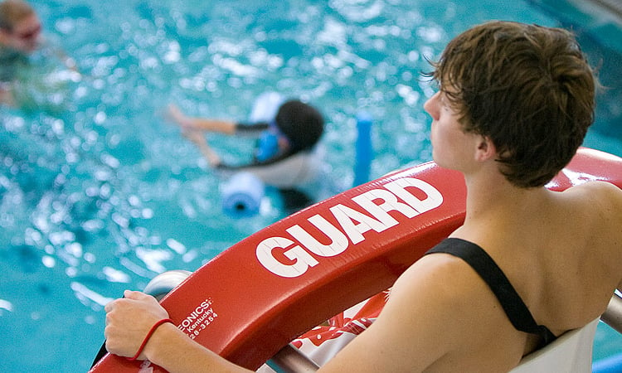

**What to Expect from Leading Lifeguard Training Programs**

No matter your location, [American Lifeguard](https://americanlifeguard.com/) strives to make high-quality training accessible either on-site or virtually. Their calendar allows searching programs by zip code to find the next available session near you. Training may be held at indoor pools, ocean side beaches or community centers to best suit different environments future guards may serve in. Reach out to discuss scheduling options that fit your schedule and needs.

**How long is a Lifeguard Training?**

On average, American Lifeguard's in-person programs last between 2-5 days depending on the level of certification desired. Basic certification including CPR/AED and basic lifeguarding skills can usually be completed in 2 days. Advanced certifications integrating waterfront or wilderness rescue may require 4-5 days. The online programs are self-paced but typically take students 1-2 months to complete at their own schedule. Re-certification courses are also offered to maintain credentials annually.

**How long does lifeguard training take**

American Lifeguard classes provide students with expert instruction from veteran lifeguards. Classes average around 10 students to ensure individualized attention. A typical training day includes classroom lectures in the morning covering theory, followed by intensive skill practice in the afternoon. Instructors use their real-world experience responding to real emergencies to prepare students for any situations they may face. Students leave feeling confident in their abilities to act decisively and protect safety as true lifeguard professionals.

**Final Words**

As the premier name in lifeguard training for over 30 years, American Lifeguard has certified hundreds of thousands of lifeguards nationwide. Their programs are accredited through leading organizations and overseen by medical safety experts. Whether becoming a lifeguard for the summer or starting a long-term career, American Lifeguard provides the gold standard in comprehensive training at an affordable cost. Their combination of expertise, accessibility and affordable options make them the top choice for lifeguard certification.